PRO-TECHT

MS. RAGAPRIYA R
Department of Information Technology
St.Joseph’s College of Engineering
OMR, Chennai.
ragagurmeet@gmail.com

MS. MALATHI V
Department of Information Technology
St.Joseph’s College of Engineering,
OMR, Chennai.
malumalathi032@gmail.com

MS. KOUSIKA V
Department of Information Technology
St.Joseph’s College of Engineering
OMR, Chennai.
kousikakousi11@gmail.com

Abstract— Social security among communities, offices or an individual house has been deprived greatly now-a-days. With other cameras monitoring people and keeping a regular track of them, our paper poses a solution to identify the culprit among the genuine.
Activity of people and any unwanted or illegal gestures are monitored. Regularly seen faces are differentiated among people who are new and seem suspicious in the vicinity.
Tracking of objects such as guns, knives and weapon are implemented to further enhance the accurate pinpoint of crime suspected individuals or groups. When such a person is identified, alert notifications are sent. This paper presents a study on criminal detection using PTZ camera.
Keywords—Introduction, Literature survey, Behaviour analysis, Image processing and gesture detection, Weapon detection, IP camera mobile push notification, Specification.

INTRODUCTION
Video surveillance has grown to be a tremendous and active area of research. Behavioral and gesture analysis together with object detection has proved to be an effective method to predict criminals.
Object detection is to track objects in every frame. Various factors like noises, occlusions, dynamic changes have been a setback in this method. It is the primary step to detect objects. It involves representation and localization.
Pan-Tilt-Zoom (PTZ) is used to monitor the intruders from a long distance. The cameras rotate or pan 340 degrees instead of the 360 continuous rotation provided by the Rapid Dome models. 3D facial recognition extends the traditional methods of facial recognition to live-stream accurate capture and identification. If you need to find the criminal entering your building or walking down the street, this is the best solution for you. It integrates with IP camera systems.

LITERATURE SURVEY
In paper [1] analyzing of human minds is proposed. Different psychological cases are examined. Traits and behaviors posed by such criminals are analyzed and are explained. The degree of psychopaths is also explained.

In paper [2] psychological explanations of criminal behavior is proposed. Crime theories, cognitive behavior analysis and behavior theories are explained. Such gestures shown by people predict them to be nervous and closed and possess the ability to perform a crime.

In paper [3] image processing methods and formulae are proposed. Formula for Gaussian smoothing, median filtering, noise reduction, and various image and background modifications technique are explained. This is widely used in PTZ camera for video surveillance.

In paper [4] concealed weapon detection using image processing is proposed. Eventual deployment and automatic detection of concealed weapons is explained. A number of sensors based on different phenomenology as well as image processing support are being developed to observe objects underneath people's clothing.

In paper [5] object tracking using PTZ camera is proposed. Tracking people or moving objects across a PTZ camera and maintaining a track within a camera is a challenging task in applications of video surveillance. The goal of object tracking is segmenting a region of interest from a video scene and keeping track of its motion, positioning and occlusion. Object tracking is performed using monitoring objects’ spatial and temporal changes during a video sequence, including its presence, position, size, shape, etc. This paper presents a study on moving object detection and tracking techniques using PTZ camera.

BEHAVIOUR ANALYSIS

1. Tools for behaviour analysis
Various tools pave way for the efficient analysis of criminals. Timing, movement of body and hands, distance, height, eyes are some of them.

2. Corporal Language Parameters for suspicious behaviour
Some of the basic parameters like rhythm and movement (eyes, hands, legs, and head), tension and freezing of diverse muscles (face, hands), defenses, barriers, tension, insecurity, nervousness and contradictions should be detected before pointing a person to be a criminal.
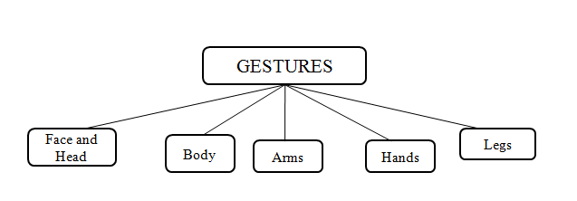

3. Basic conditions to be detected
3.1 Defense and barriers
- Hands cross on the chest and fallen head with tight lips.
- Hands hiding part of the body.
3.2 Tension
- Superficial breathing with strongly interlaced hands or fingers.
- Lack of flexibility and coordination of movements.
- Suspicious movement of eyes.
3.3 Nervousness
- Quake in the legs, hands with threatening gestures and contracted lips
- Crossed arms and legs with looks of worry and anxiety.
3.4 Insecurity
- Numerous head movements with small movements of hands.
- Lack of vitality in movement with short steps.
3.5 Contradictions
- Incomplete smile and threatening facial features with retiring legs.
- Smile with frozen body, cold looking and closed gestures.
4. Iris Movement

4.1 Horizontal left and right looks indicate identifying new sounds and remembering known sounds.
4.2 Looking down and left indicates decision making.
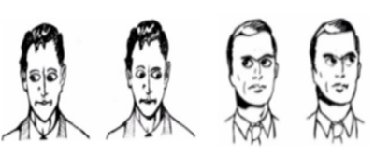

5. Face fuse
Face tracking with cylinder head models is used to fuse faces and identify them using still face recognition method, Eigen faces, Gaussian weight and average half wave method. The process of classification of a new (unknown) face to one of the classes (known faces) proceeds in two steps. First, the new image is transformed into its Eigen face components. The resulting weights form the weight vector.
The Euclidean distance between two weight vectors d(i,j) provides a measure of similarity between the corresponding images i and j. If the Euclidean distance between new and other faces exceeds - on average - some threshold value, one can assume that there is no face at all. d(i,j) also allows one to construct “clusters” of faces such that similar faces are assigned to one cluster.

Euclidean Distance
Let¹ an arbitrary instance x be described by the feature vector
where a_{r}(x) denotes the value of the rth attribute of instance x. Then the distance between two instances x_{i} and x_{j} is defined to be d(x_{i},x_{j}).

Notations
I | Face image
N × N | Size of I
 | Training set
_{i} | Face image i of the training set
_{new} | New (unknown) image
 | Average face
M = || | Number of Eigen faces
M' | Number of eigen faces used for face recognition
C | Covariance matrix
X^{T} | Transposed X (if X is a matrix)
u | Eigenvector (eigenface)
 | Eigenvalue
_{i} | Weight i
_{i}^{T} | Weight vector of the image i
 | Threshold value

IV. IMAGE PROCESSING AND GESTURE DETECTION

- Objectives
- Segmentation of video frames
- Image morphology and connected component analysis
- Optical flow analysis
- Camera control parameters
- Background Subtraction
Resultant background subtracted image is obtained from two distinguishable frameworks depending on threshold frequencies.

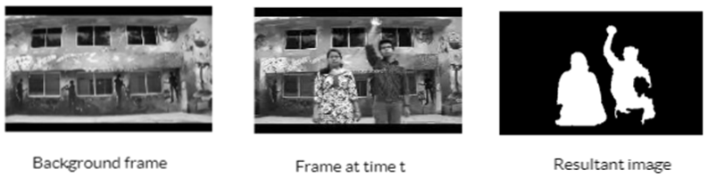

B(x,y,t)=I(x,y,t-1)
=|I(x,y,t)-I(x,y,t-1)|>Th
Notations
I Image at time t
B Background at time t
Th Threshold

- Frame Differencing

The figures below show two consecutive frames taken from a video and the resultant frame difference. This is followed by erosion of an unfiltered frame.
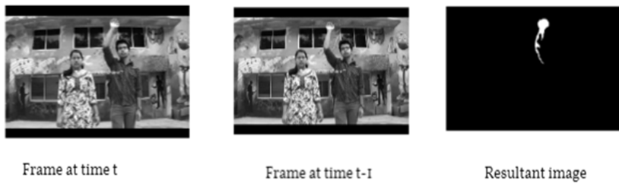
|frame(i)-frames(i-1)|>Th

- Connected component labeling

Connected component labeling is applied in the below figure to label the people in the image separately and match the moving hand to detect the gesture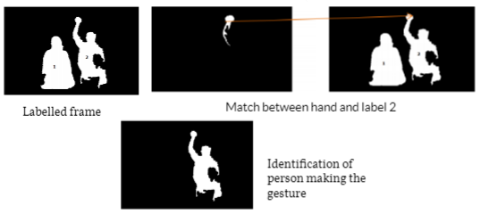

- Optical flow analysis and motion detection

Optical flow technique is applied to a live feed obtained from an IP camera. The box bounded indicates the region where motion was detected.
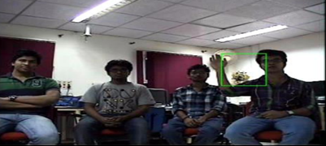
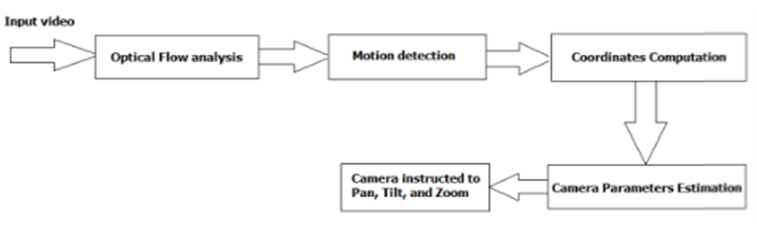

Block diagram for the complete process of PTZ determination

V. WEAPON DETECTION

Objectives of weapon detection:
- Detect human in an image
- Detection of segment containing weapon in the human segment.
- Extraction of features for each segment.
- Design of neural network based classifier to classify a single type of weapon versus non-weapon.
- Computation time required to detect a weapon directly in an image comparatively to detection of weapon after human detection.
- Design multi class classifier to classify two types of weapons- knives and guns.

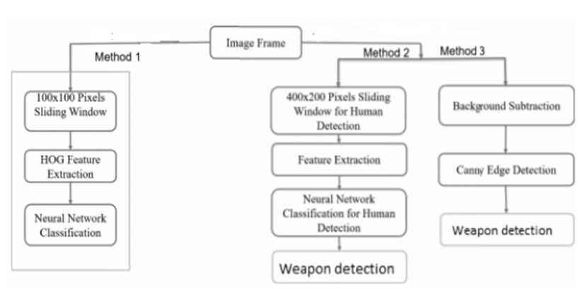
- Sliding Window
The window is slid horizontally by certain number of pixels to find the desired image segment.
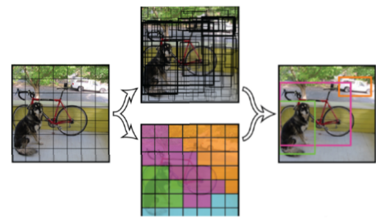
- Histogram of Oriented Gradients
HOG is a feature descriptor used in computer vision, image processing for the purpose of object detection.
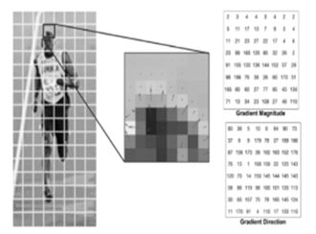

- Artificial Neural Networks
ANN is inspired by biological neural networks. An artificial neuron that receives a signal can process it and then signal additional artificial neuron connected to it.
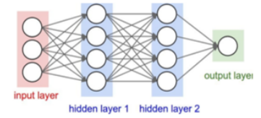

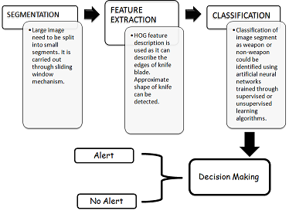
Process for weapon detection

VI. IP CAMERA MOBILE APP PUSH NOTIFICATION
- Steps for Notification from camera to mobile

- Set up Pushbullet
- Download software
- Flash image to Pi
- Enter the Pushbullet access token
- Play around
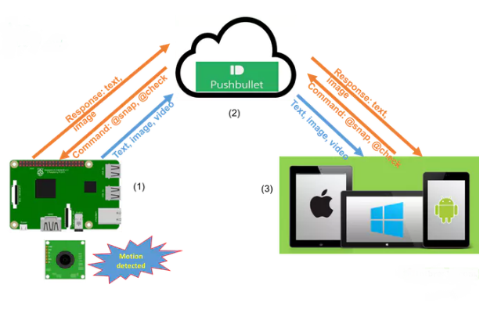
- Under the hood
The python files needed are:
- main.py- logical application. Initialize camera and detect motion at command received.
- push.py- init push manager. Sends notifications and receives command.
- Log
It is written to file /home/pi/Desktop /PiCameraNotifier/run.log. in case an error happens or you want to check the running status, you can change the file path by modifying the variable LOG_FILE_PATH in main.py.
- Auto launch the app at pi boot/reboot
The application is up running automatically after rebooting the Pi. We use the systemctl to config the PiCameraNotifier as a service that runs in the background.

VII. SPECIFICATION
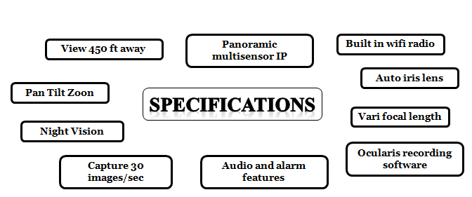

References
[1] Don Jacobs, “Analyzing Criminal Minds”, Oxford, England published in 2011.

[2] Ian Marsh, “Psychological Explanations for Criminal Behavior”, published in 2011.

[3] Ian T. Young, Jan J. Gerbrands, Lucas J. van Vliet, “Fundamentals of Image Processing”, Delft University of Technology 2007.

[4] Bhavna Khajone, Prof. V. K. Shandilya, “Concealed Weapon Detection Using Image Processing”, International Journal of Scientific & Engineering Research, Volume 3, Issue 6, June-2012 1 ISSN 2229-5518.

[5] Hetal K. Chavda, Prof. Maulik Dhamecha, “A Study on Moving Object Tracking Using PTZ Camera in Video Surveillance System”, PG Student, Department of Computer Engineering Assistant Professor, Department of Computer Engineering VVP Engineering College, Rajkot, Gujarat, India.

